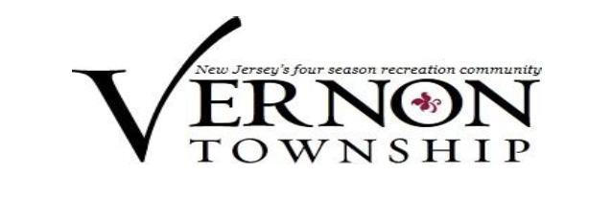
Vernon Township Environmental Commission
March 18, 2024

CALL TO ORDER

STATEMENT OF COMPLIANCE: Pursuant to the Open Public Meetings Act, Chapter 231, PL 1975, adequate notice as defined in Section 3D of Chapter 231, PL 1975 of this Regular Meeting has been provided to the public and the press on February 20, 2024, by delivering
to the press such notice and posting same at the Municipal Building and filed with the office of the Township Clerk.

SALUTE TO THE FLAG

ROLL CALL
Stephanie DiBrienza - Chairperson
Ann Larsen - Vice Chair & LUB Liaison
Debbie Coulson
Catherina Sawoszczyk
Barbara Jaggi

Public Participation – Agenda items only

APPROVAL OF MINUTES
January 29, 2024

Recording Secretary - Discussion

Land Use Board Liaison Report

Land Use Board Applications Under Review - NONE

OLD BUSINESS
Charging Stations – Town Council Ordinance and Grants

NEW BUSINESS
Silver Spruce Drive Analytical Testing Results
Elizabethtown Gas Leak
Tree distribution at Earth Fest – April 13, 2024

Public Participation

Commissioner Comments

ADJOURNMENT – Next Meeting April 15, 2024

